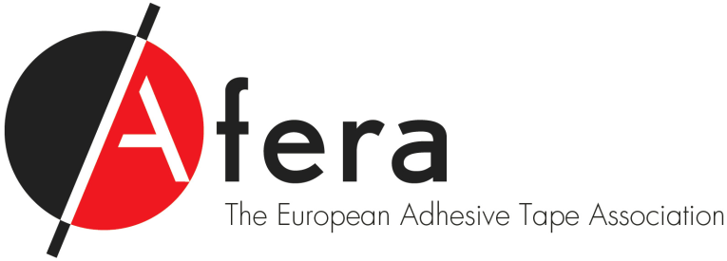

**Commodity/packaging tape manufacturers:**

**How can Afera be *your* voice?**

As the European Adhesive Tape Association, Afera brings together the key decision-makers and innovators of the European tape industry in a total commitment to enhancing the sector’s sustainable growth. Open for membership to businesses and organisations involved in the European adhesive tape industry, Afera is a non-profit association providing a medium for facilitating contact, sharing tools and information, promoting tape technology, developing and adhering to European and international standards, and monitoring and representing the industry in regulatory affairs initiatives. Afera acts as *the* voice of the European tape industry.

**2/3 of Europe’s tape manufacturers make packaging & other commodity tapes**

Afera’s adhesive tape manufacturer member companies make up 65% of Europe’s tape manufacturers in total. 30% of those are commodity tape manufacturers, which produce packaging tapes, masking tapes, and consumer and office tapes. The market for commodity tapes accounts for about two-thirds of total tape demand. European commodity tape manufacturers are increasingly focussing on sourcing raw materials, lowering costs, and improving quality. Afera is just the association to help you do this.

**What are you looking for in an association specialising in your industry?**

* **Contacts?**
  + Afera’s Membership comprises the majority of adhesive tape industry players, including over 100 manufacturers, distributors, raw materials, packaging and machine suppliers, converters, research institutions and universities, national tape organisations and other international counterparts, from 20 European countries
  + Afera’s events and meetings bring together Europe’s best and brightest tape business professionals multiple times a year
* **Learning and informational events?**
  + Afera’s Annual Conference, Technical Seminar and Tape College offer you access to the latest information on economic trends and drivers, market data and segments, product and technology development, content marketing, company management, and European regulatory issues affecting the tape industry
  + Afera Members also benefit from and participate in focussed committees and working groups
* **Technical standards development and harmonisation?**
  + Afera’s Technical Committee routinely develops test methods and co-operates at the European and global level on standardisation issues
* **Representation on European legislative issues?**
  + Afera co-operates with and represents European tape manufacturers on European regulatory matters concerning the environment and product safety
* **Tools and information sharing for planning your business?**
  + Afera makes valuable industry studies (such as Freedonia’s 2014 global tape study), surveys, publications, and other information exclusively available to its Members.

**What would you like to get out of membership in a specialised European industry association?**

* Events held at a certain (type of) geographical location?
* More of a certain type or category of event participant, i.e. more tape manufacturers, raw materials suppliers, packaging suppliers, machine suppliers, distributors, or converters?
* More event presentations on sourcing raw materials and machinery, increasing quality and efficiency, lowering costs, improving supply lines, adhering to environmental/product safety legislation, or analysing market data and trends (such as the Freedonia study)?
* Event presentations given by multinational customers?
* A special 2-hour presentation created on increasing efficiency and lowering costs (raw materials, substrates, machines, etc.)?
* Events in which different breakout sessions for commodity- and specialty tape professionals are created?
* Longer coffee breaks and meeting rooms made available between and after presentations to accommodate networking?
* Separate events created specifically for commodity/packaging tape manufacturers?
* Language translation services at Afera events?
* Lower event participation fees?
* More openness to customers/a different alignment of the Association towards industry stakeholders?
* Representation on a specific standardisation or regulatory issue?
* Lower membership fees?

**Tell us what’s on your mind**

Are we missing something? Afera wants to know what you would like to get out of an association membership. Contact us at Afera’s Secretariat on +31 (0)70 312 39 16 or via [mail@afera.com](mailto:mail@afera.com). For more information about Afera’s mission, activities and membership, visit [afera.com](http://www.afera.com).